Packet sniffing project

Python code for this mto develop this one

**# packet-sniffer/app.py**

from scapy.all import sniff, IP, TCP, UDP, ICMP

from datetime import datetime

import argparse

def proto_of(pkt):

if TCP in pkt: return "TCP"

if UDP in pkt: return "UDP"

if ICMP in pkt: return "ICMP"

if IP in pkt: return f"IP proto {pkt[IP].proto}"

return pkt.name

def handle(pkt):

ts = datetime.now().strftime("%H:%M:%S")

if IP in pkt:

print(f"[{ts}] {pkt[IP].src} -> {pkt[IP].dst} | {proto_of(pkt)} | len={len(pkt)}")

else:

print(f"[{ts}] {pkt.summary()}")

parser = argparse.ArgumentParser(description="Simple packet sniffer (Stage A)")

parser.add_argument("-i","--iface", default=None, help="Interface, e.g., eth0/wlan0/ens33")

parser.add_argument("-f","--filter", default="ip", help="BPF filter (e.g., 'tcp', 'udp', 'port 53')")

parser.add_argument("-c","--count", type=int, default=0, help="Packets to capture (0=infinite)")

args = parser.parse_args()

sniff(prn=handle, store=False, iface=args.iface, filter=args.filter, count=args.count)

**Advance**

# packet-sniffer/app.py (Stage B: CSV + PCAP)

from scapy.all import sniff, IP, TCP, UDP, ICMP

from scapy.utils import PcapWriter

from datetime import datetime

from pathlib import Path

import argparse, csv

def proto_of(pkt):

if TCP in pkt: return "TCP"

if UDP in pkt: return "UDP"

if ICMP in pkt: return "ICMP"

if IP in pkt: return f"IP proto {pkt[IP].proto}"

return pkt.name

def main():

parser = argparse.ArgumentParser(description="Packet sniffer with CSV/PCAP logging")

parser.add_argument("-i","--iface", default=None, help="Interface (e.g., eth0/wlan0/ens33)")

parser.add_argument("-f","--filter", default="ip", help="BPF filter (e.g., 'tcp', 'udp', 'port 53')")

parser.add_argument("-c","--count", type=int, default=0, help="Packets to capture (0=infinite)")

args = parser.parse_args()

# prepare paths

base_dir = Path(__file__).resolve().parent

log_dir = base_dir / "logs"

log_dir.mkdir(parents=True, exist_ok=True)

stamp = datetime.now().strftime("%Y%m%d_%H%M%S")

csv_path = log_dir / f"packets_{stamp}.csv"

pcap_path = log_dir / f"packets_{stamp}.pcap"

# writers

csv_file = open(csv_path, "w", newline="")

csv_writer = csv.writer(csv_file)

csv_writer.writerow(["time","src","dst","proto","length"])

pcap = PcapWriter(str(pcap_path), append=True, sync=True)

print(f"[+] Writing CSV -> {csv_path}")

print(f"[+] Writing PCAP -> {pcap_path}")

print(f"[+] Sniffing on iface={args.iface or 'DEFAULT'} filter='{args.filter}' count={args.count or '∞'}")

print("[+] Ctrl+C to stop")

def handle(pkt):

# write PCAP first (every packet)

pcap.write(pkt)

# pretty console line + CSV row if IP present

ts = datetime.now().strftime("%H:%M:%S")

if IP in pkt:

src, dst = pkt[IP].src, pkt[IP].dst

proto = proto_of(pkt)

length = len(pkt)

print(f"[{ts}] {src} -> {dst} | {proto} | len={length}")

csv_writer.writerow([ts, src, dst, proto, length])

else:

print(f"[{ts}] {pkt.summary()}")

try:

sniff(prn=handle, store=False, iface=args.iface, filter=args.filter, count=args.count)

except KeyboardInterrupt:

pass

finally:

csv_file.flush(); csv_file.close()

print("[+] Stopped. CSV/PCAP saved.")

if __name__ == "__main__":

main()

**# day 5 code**

from scapy.all import sniff, IP

import csv

import argparse

import os

# Ensure logs folder exists

os.makedirs("logs", exist_ok=True)

def packet_callback(packet):

if IP in packet:

with open("logs/day5_sniffer.csv", "a", newline="") as f:

writer = csv.writer(f)

writer.writerow([

packet[IP].src,

packet[IP].dst,

packet[IP].proto,

len(packet)

])

print(f"[+] {packet[IP].src} -> {packet[IP].dst} | Proto: {packet[IP].proto} | Len: {len(packet)}")

if __name__ == "__main__":

parser = argparse.ArgumentParser()

parser.add_argument("-i", "--iface", required=True, help="Network interface (e.g., eth0, wlan0, lo)")

parser.add_argument("-c", "--count", type=int, default=20, help="Number of packets to capture")

args = parser.parse_args()

# Initialize CSV file with headers

with open("logs/day5_sniffer.csv", "w", newline="") as f:

writer = csv.writer(f)

writer.writerow(["Source IP", "Destination IP", "Protocol", "Length"])

print(f"[!] Starting sniffer on {args.iface}, capturing {args.count} packets...")

sniff(iface=args.iface, prn=packet_callback, count=args.count)

print("[✔] Capture finished. Saved to logs/day5_sniffer.csv")

Day 6 code

# packet-sniffer/app.py (Stage B: CSV + PCAP)

from scapy.all import sniff, IP, TCP, UDP, ICMP

from scapy.utils import PcapWriter

from datetime import datetime

from pathlib import Path

import argparse, csv

def proto_of(pkt):

if TCP in pkt: return "TCP"

if UDP in pkt: return "UDP"

if ICMP in pkt: return "ICMP"

if IP in pkt: return f"IP proto {pkt[IP].proto}"

return pkt.name

def main():

parser = argparse.ArgumentParser(description="Packet sniffer with CSV/PCAP logging")

parser.add_argument("-i","--iface", default=None, help="Interface (e.g., eth0/wlan0/ens33/lo)")

parser.add_argument("-f","--filter", default="ip", help="BPF filter (e.g., 'tcp', 'udp', 'port 53')")

parser.add_argument("-c","--count", type=int, default=0, help="Packets to capture (0=infinite)")

args = parser.parse_args()

# prepare paths

base_dir = Path(__file__).resolve().parent

log_dir = base_dir / "logs"

log_dir.mkdir(parents=True, exist_ok=True)

stamp = datetime.now().strftime("%Y%m%d_%H%M%S")

csv_path = log_dir / f"packets_{stamp}.csv"

pcap_path = log_dir / f"packets_{stamp}.pcap"

# writers

csv_file = open(csv_path, "w", newline="")

csv_writer = csv.writer(csv_file)

csv_writer.writerow(["time","src","dst","proto","length"])

pcap = PcapWriter(str(pcap_path), append=True, sync=True)

print(f"[+] Writing CSV -> {csv_path}")

print(f"[+] Writing PCAP -> {pcap_path}")

print(f"[+] Sniffing on iface={args.iface or 'DEFAULT'} filter='{args.filter}' count={args.count or '∞'}")

print("[+] Ctrl+C to stop")

def handle(pkt):

# write PCAP first (every packet)

pcap.write(pkt)

# pretty console line + CSV row if IP present

ts = datetime.now().strftime("%H:%M:%S")

if IP in pkt:

src, dst = pkt[IP].src, pkt[IP].dst

proto = proto_of(pkt)

length = len(pkt)

print(f"[{ts}] {src} -> {dst} | {proto} | len={length}")

csv_writer.writerow([ts, src, dst, proto, length])

else:

print(f"[{ts}] {pkt.summary()}")

try:

sniff(prn=handle, store=False, iface=args.iface, filter=args.filter, count=args.count)

except KeyboardInterrupt:

pass

finally:

csv_file.flush(); csv_file.close()

print("[+] Stopped. CSV/PCAP saved.")

if __name__ == "__main__":

main()

**day 7 code**

**# packet-sniffer/app.py (Stage C: Filtering + Summary)**

**from scapy.all import sniff, IP, TCP, UDP, ICMP**

**from scapy.utils import PcapWriter**

**from datetime import datetime**

**from pathlib import Path**

**import argparse, csv**

**def proto_of(pkt):**

**if TCP in pkt: return "TCP"**

**if UDP in pkt: return "UDP"**

**if ICMP in pkt: return "ICMP"**

**if IP in pkt: return f"IP proto {pkt[IP].proto}"**

**return pkt.name**

**def main():**

**parser = argparse.ArgumentParser(description="Packet sniffer with filters + summary")**

**parser.add_argument("-i","--iface", default=None, help="Interface (e.g., eth0/wlan0/ens33)")**

**parser.add_argument("-f","--filter", default="ip", help="BPF filter (e.g., 'tcp', 'udp', 'port 53')")**

**parser.add_argument("-c","--count", type=int, default=0, help="Packets to capture (0=infinite)")**

**args = parser.parse_args()**

**# paths**

**base_dir = Path(__file__).resolve().parent**

**log_dir = base_dir / "logs"**

**log_dir.mkdir(parents=True, exist_ok=True)**

**stamp = datetime.now().strftime("%Y%m%d_%H%M%S")**

**csv_path = log_dir / f"packets_{stamp}.csv"**

**pcap_path = log_dir / f"packets_{stamp}.pcap"**

**# writers**

**csv_file = open(csv_path, "w", newline="")**

**csv_writer = csv.writer(csv_file)**

**csv_writer.writerow(["time","src","dst","proto","length"])**

**pcap = PcapWriter(str(pcap_path), append=True, sync=True)**

**# counters**

**stats = {"TCP":0, "UDP":0, "ICMP":0, "OTHER":0}**

**print(f"[+] Writing CSV -> {csv_path}")**

**print(f"[+] Writing PCAP -> {pcap_path}")**

**print(f"[+] Sniffing on iface={args.iface or 'DEFAULT'} filter='{args.filter}' count={args.count or '∞'}")**

**print("[+] Ctrl+C to stop")**

**def handle(pkt):**

**pcap.write(pkt)**

**ts = datetime.now().strftime("%H:%M:%S")**

**if IP in pkt:**

**src, dst = pkt[IP].src, pkt[IP].dst**

**proto = proto_of(pkt)**

**length = len(pkt)**

**print(f"[{ts}] {src} -> {dst} | {proto} | len={length}")**

**csv_writer.writerow([ts, src, dst, proto, length])**

**if proto in stats:**

**stats[proto] += 1**

**else:**

**stats["OTHER"] += 1**

**try:**

**sniff(prn=handle, store=False, iface=args.iface, filter=args.filter, count=args.count)**

**except KeyboardInterrupt:**

**pass**

**finally:**

**csv_file.flush(); csv_file.close()**

**print("\n[+] Capture finished. Summary:")**

**for k,v in stats.items():**

**print(f" {k}: {v} packets")**

**print("[+] CSV/PCAP saved.")**

**if __name__ == "__main__":**

**main()**

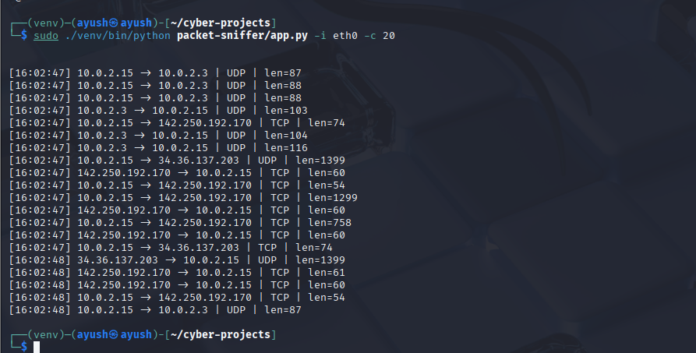

Adv

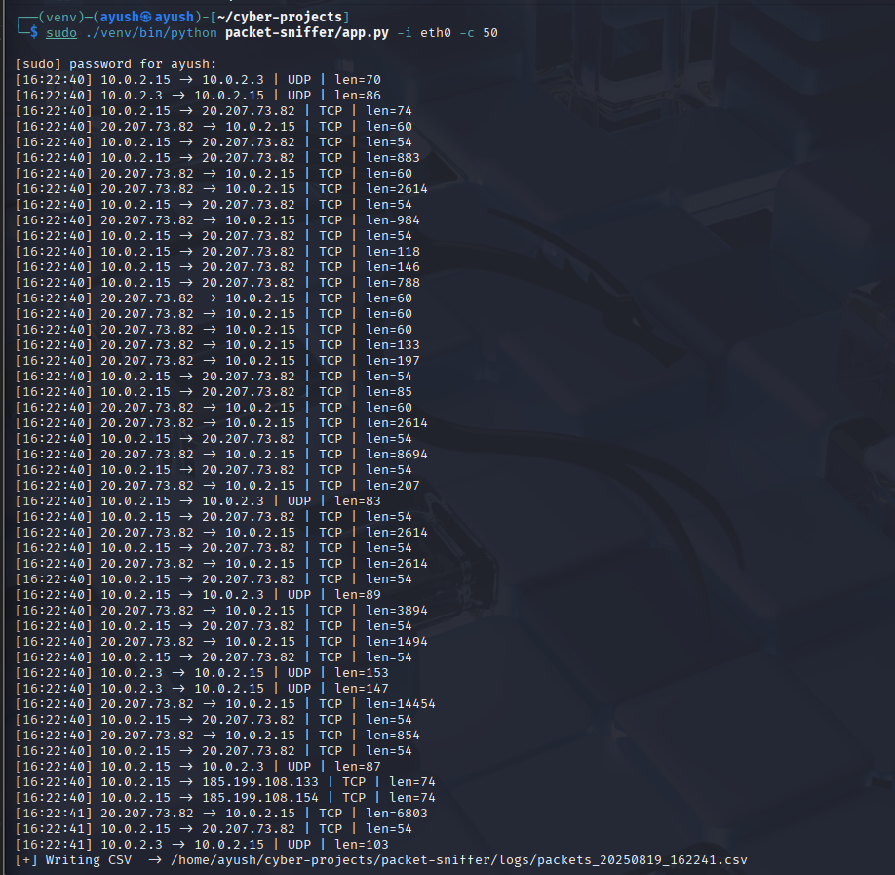

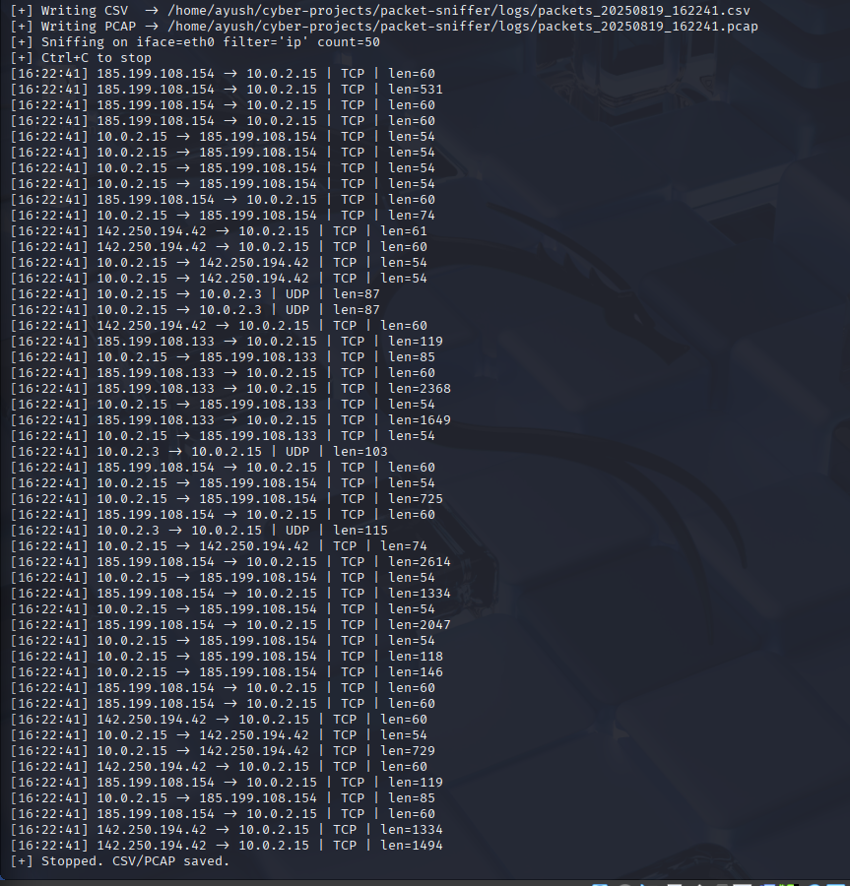

Day 5

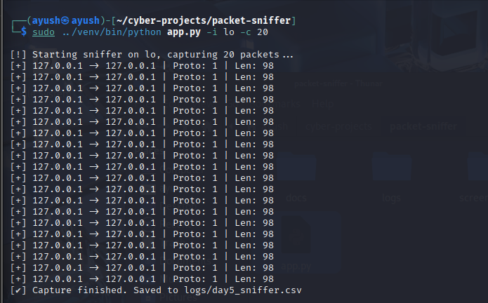

Day 6

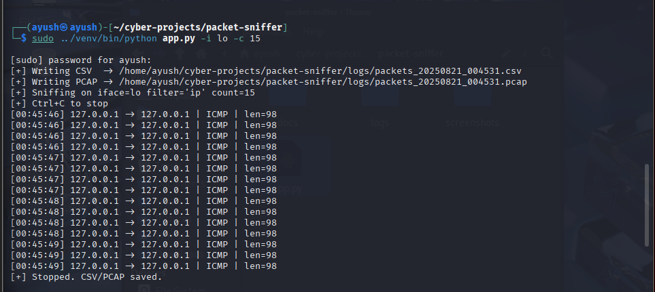

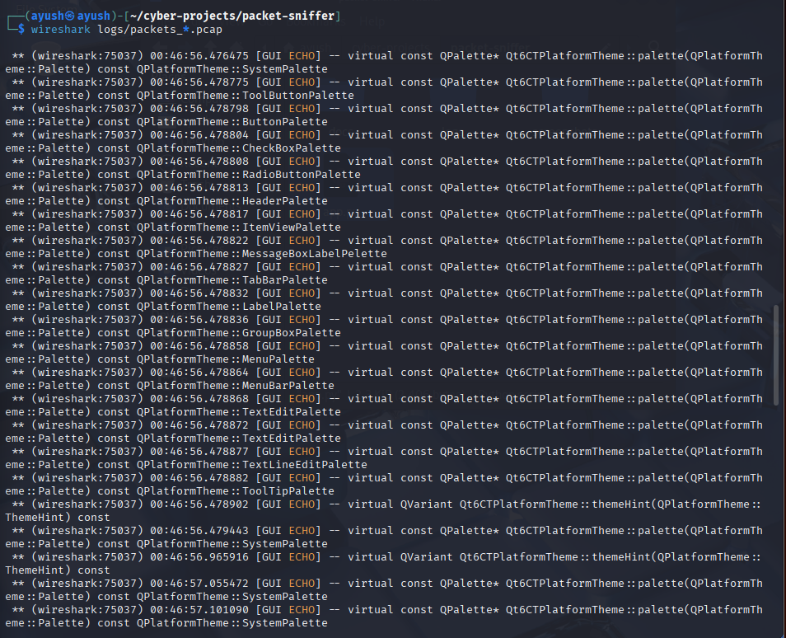

Day 7 output

